Task 1:
Basic Test Case
import org.junit.jupiter.api.Assertions;
import org.junit.jupiter.api.BeforeAll;
import org.junit.jupiter.api.Test;
public class CalculatorTest {
static Calculator calc;
@BeforeAll
static void initializeObjects(){
calc = new Calculator();
}
@Test
void additionPass() {
// Calculator calc = new Calculator();
Assertions.assertEquals(15, calc.add(10, 5), "Expected 15");
}
@Test
void additionFail(){
// Calculator calc = new Calculator();
Assertions.assertNotEquals(20,calc.add(10,15),"Expected Values should never equals");
}
}

Task 2: Bank Application
import java.util.UUID;
public class BankAccount {
private final String accountNumber;
private double balance;
public BankAccount(){
this.accountNumber = UUID.randomUUID().toString();
}
public void deposit(double amount){
if(amount <0 ) throw new IllegalArgumentException("Invalid ammount");
this.balance += amount;
}
public boolean withdraw(double amount){
if(this.balance < amount) throw new IllegalArgumentException("Insufficient Balance");
this.balance -= amount;
return true;
}
public String getAccountNumber(){
return this.accountNumber;
}
}

import org.junit.jupiter.api.Test;
import org.junit.jupiter.api.Assertions;
import java.io.FileNotFoundException;
public class BankAccountTest {
@Test
void withdraw_insufficientBalance_throwsException(){
BankAccount bankAccount = new BankAccount();
bankAccount.deposit(100);
Exception ex = Assertions.assertThrows(IllegalArgumentException.class,()->{
bankAccount.withdraw(200);
});
Assertions.assertEquals(ex.getMessage(),"Insufficient Balance");
}
@Test
void withdraw_sufficientBalance_returnTrue(){
BankAccount bankAccount = new BankAccount();
bankAccount.deposit(100);
Assertions.assertTrue(bankAccount.withdraw(100));
}
}

Task 03:
For above code create fail test cases

import org.junit.jupiter.api.Test;
import org.junit.jupiter.api.Assertions;
import java.io.FileNotFoundException;
public class BankAccountTest {
// methodName_condition_expectedResult
@Test
void withdraw_insufficientBalance_throwsException(){
// Arrange
BankAccount bankAccount = new BankAccount();
bankAccount.deposit(100);
// Act
Exception ex = Assertions.assertThrows(FileNotFoundException.class,()->{
bankAccount.withdraw(200);
});
// Assert
Assertions.assertEquals(ex.getMessage(),"Insufficient Balance");
}
@Test
void withdraw_sufficientBalance_returnTrue(){
// Arrange
BankAccount bankAccount = new BankAccount();
bankAccount.deposit(100);
// Act
boolean transactionResult = bankAccount.withdraw(200);
// Assert
Assertions.assertTrue(transactionResult);
}
}

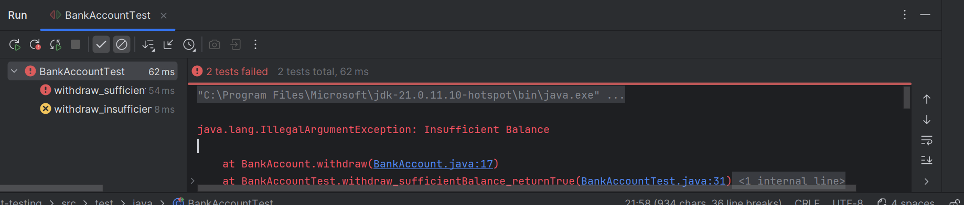

Task 04:
Create a java code for the Parameterised Test case

public class StringUtilFunctions {
public static boolean isPalindrome(String s){
int i=0;
int j = s.length()-1;
while(i<j){
if(s.charAt(i) != s.charAt(j) ){
return false;
}
i++;
j--;
}
return true;
}
}

import org.junit.jupiter.api.Test;
import org.junit.jupiter.api.Assertions;
import org.junit.jupiter.params.ParameterizedTest;
import org.junit.jupiter.params.provider.ValueSource;
public class StringUtilFunctionsTest {
@ParameterizedTest
@ValueSource(strings = {"mom","sos"})
void isPalindrome_validateMultipleArgs_true(String name){
// Act
boolean res = StringUtilFunctions.isPalindrome(name);
// Assert
Assertions.assertTrue(res);
}
}

Task 05:
What is Junit Life cycle hook (set up tear down) ?
Junit life cycle hooks are special methods that run before and after test execution
They helps to prepare test data & clean up resources
Purpose:
Setup: initialize objects, test data, database connection etc.
Teardown: Release resources, clear data, close connections etc.
Example: BeforeEach, AfterEach, BeforeAll, AfterAll

@BeforeAll
↓
@BeforeEach
↓
@Test
↓
@AfterEach
↓
(repeat for each test)
↓
@AfterAll

Task 06:
Create a java code for life cycle hook setup/ tear down test file
import java.util.HashMap;
import java.util.Map;
public class DatabaseService {
private Map<String,String> records;
private boolean connected;
public DatabaseService(){
records = new HashMap<>();
}
public void connect(){
this.connected = true;
}
public void disconnect(){
this.connected = false;
}
public boolean isConnected(){
return this.connected;
}
public void insert(String key,String val){
if (!connected) {
throw new IllegalStateException("Database not connected");
}
records.put(key,val);
}
public String fetch(String key){
if (!connected) {
throw new IllegalStateException("Database not connected");
}
return records.get(key);
}
public void delete(String key){
if (!connected) {
throw new IllegalStateException("Database not connected");
}
records.remove(key);
}
}

import org.junit.jupiter.api.*;
public class DatabaseServiceTest {
static DatabaseService databaseService;
@BeforeAll
static void setup(){
databaseService = new DatabaseService();
}
@AfterAll
static void cleanup(){
databaseService = null;
}
@BeforeEach
void connectToDB(){
databaseService.connect();
}
@AfterEach
void disconnectFromDB(){
databaseService.disconnect();
}
@Test
void insert_insertData_fetchData(){
// Arrange
databaseService.insert("1","apple");
// Act
String res = databaseService.fetch("1");
// Assert
Assertions.assertEquals(res,"apple");
}
@Test
void fetch_missingVal_returnsNull(){
String res = databaseService.fetch("4");
Assertions.assertEquals(res,null);
}
@Test
void insert_duplicateKey_overwritesExistingValue() {
databaseService.insert("user1", "Prasunamba");
databaseService.insert("user1", "Anjali");
Assertions.assertEquals(
"Anjali",
databaseService.fetch("user1")
);
}
@Test
void insert_whenDisconnected_throwsException() {
databaseService.disconnect();
Exception ex = Assertions.assertThrows(
IllegalStateException.class,
() -> databaseService.insert("user1", "Prasunamba")
);
Assertions.assertEquals(
"Database not connected",
ex.getMessage()
);
}
}

Task 07:
What are assertions in Junit 5.. Explain
Assertions are methods provided by Junit 5 that are used to verify whether the actual result matches the expected result
Common method: assertTrue, assertEquals, assertNotEquals, assertFalse, assertNull, assertNotNull, assertThrows, assertAll,

Task 08:
What is time test performance service means 👍?
Time test in Junit is used to verify that piece of code executes with a specific time limit.
It helps to ensure that application performance is acceptable and operations do not take long time to complete
In Junit we uses a assertTimeout & assertTimeoutPreemptively
methods to validate this

import org.junit.jupiter.api.Test;
import org.junit.jupiter.api.Assertions;
import java.time.Duration;
public class Performance_Time_Test {
@Test
void testDBLatency(){
Assertions.assertTimeout(Duration.ofSeconds(2),()->{
Thread.sleep(3000);
});
}
}

Task 09:
For the given timeout test Performance Service can you create a java code
import org.junit.jupiter.api.BeforeAll;
import org.junit.jupiter.api.Test;
import org.junit.jupiter.api.Assertions;
import java.time.Duration;
public class Performance_Time_Test {
static PerformanceService performanceService;
@BeforeAll
static void setup(){
performanceService = new PerformanceService();
}
@Test
void quickOperation_execute100MS_success(){
Assertions.assertTimeout(Duration.ofMillis(500),()->{
performanceService.quickOperatin();
});
}
@Test
void slowOperation_executesFor1000MS_failure(){
Assertions.assertTimeout(Duration.ofMillis(500),()->{
performanceService.slowOperatin();
});
}
}
import org.junit.jupiter.api.BeforeAll;
import org.junit.jupiter.api.Test;
import org.junit.jupiter.api.Assertions;
import java.time.Duration;
public class Performance_Time_Test {
static PerformanceService performanceService;
@BeforeAll
static void setup(){
performanceService = new PerformanceService();
}
@Test
void quickOperation_execute100MS_success(){
Assertions.assertTimeout(Duration.ofMillis(500),()->{
performanceService.quickOperatin();
});
}
@Test
void slowOperation_executesFor1000MS_failure(){
Assertions.assertTimeout(Duration.ofMillis(500),()->{
performanceService.slowOperatin();
});
}
}
Task 10:
Now what do you think are the different types of Junit 5 tests we have … list them down
- Unit Test: test a small unit of code, usually single method
- Exception tests: verifies that method throws the expected exception
- Lifecycle hook tests: uses setup & teardown methods
- Performance / Timeout test: Checks the code completes within a specific time
- Parametarized test: runs the same test multiple times with different inputs
- Repeated Test: runs the same test multiple times.
- Nested Test: groups related test together
- Disable Test: temporarily skip a test
- Integration Test: test integrates between multiple components

Task 11:
Write about JVM architecture using a diagram.
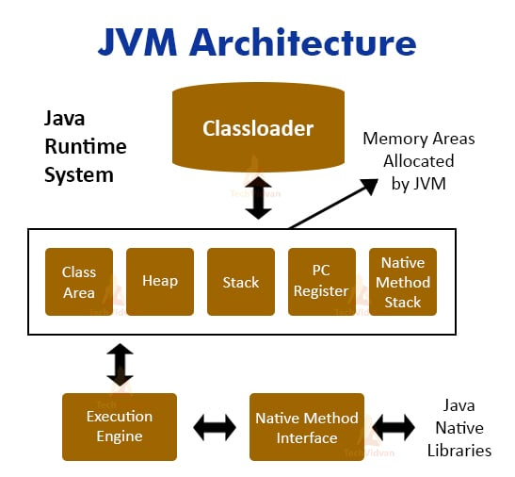JVM
(Java Virtual Machine) is a part of the Java Runtime Environment (JRE) that executes Java bytecode and enables Java's "Write Once, Run Anywhere" feature.
When a Java program is compiled, the source code (.java) is converted into bytecode (.class), which is then executed by the JVM.
Its main components are the Class Loader Subsystem, Runtime Data Areas (Method Area, Heap, Stack, PC Register, Native Method Stack), Execution Engine (Interpreter, JIT Compiler, Garbage Collector), JNI, and Native Libraries.
The JVM provides platform independence, memory management, and automatic garbage collection, enabling Java programs to run on any system that has a JVM installed.

Task 12:
Why are enums useful?
Enums are special data types in java which helps to define set of constant values
Enums prevent data inconsistencies across the codebase & improves the code quality and maintenaility

